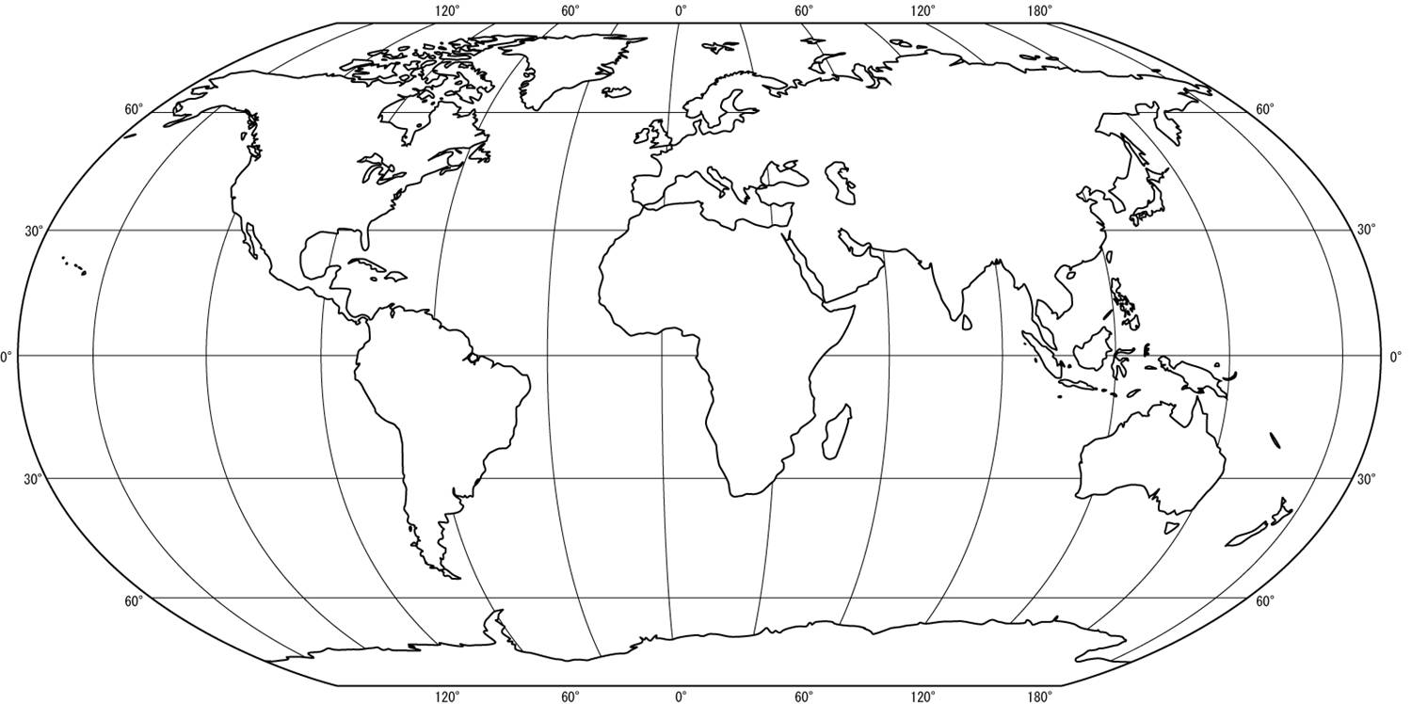
ECOSISTEMA:_______________________

